**A time-varying fiscal reaction function for brazil**

**Uma função de reação fiscal variante no tempo para o brasil**

Eduardo Lima Campos[1]

Rubens Penha Cysne[2]

**Abstract**

This paper evaluates the sustainability of public debt in Brazil using monthly data from January 2003 to June 2016, based on the estimation of fiscal reaction functions with time-varying coefficients. Three estimation methods are considered: Kalman filter, penalized spline smoothing and time-varying cointegration. Besides indicating that the reaction of the primary deficit to variations in the debt/GDP ratio declined over most of the analyzed period, all these methods lead to the conclusion that the Brazilian public debt, given the parameters then in force, reached an unsustainable trajectory in the last years of the sample.

**Key words**:public debt, sustainability, fiscal reaction function, time-varying models, Kalman filter, penalized spline smoothing, time-varying cointegration. JEL classification codes: H 30, H 60, E 50.

**Resumo**

Este artigo avalia a sustentabilidade da dívida pública brasileira usando dados mensais de janeiro de 2003 a junho de 2016 baseado na estimação de funções de reação fiscal cujos coeficientes variam ao longo do tempo. Consideramos três métodos de estimação: filtro de Kalman, suavização por spline penalizado e cointegração variante no tempo. Além de indicar uma redução da variação do déficit primário em resposta a variações da razão dívida/PIB ao longo da maior parte do período analisado, todos eles levam à conclusão de que a dívida pública brasileira, dados os parâmetros vigentes, atingiram uma trajetória insustentável nos últimos anos da amostra.

**Palavras-chave:** dívida pública, sustentabilidade, função de reação fiscal, modelos variantes no tempo, filtro de Kalman, suavização por spline penalizado, cointegração variante no tempo. Códigos JEL: E62, H63.

1. **Introduction**

Public debt in Brazil has been growing rapidly in recent years. For example, between the fourth quarter of 2013 and the second quarter of 2016, general-government gross debt rose from 51.7% to 68.5% of the country's Gross Domestic Product (GDP), and consolidated public sector net debt rose from 30.6% to 42% of GDP (BCB, 2016). Factors that contributed to this increase were not only the high and successive primary deficits (expenses - excluding interest payments - minus revenues), but also an interest rate systematically higher than the product growth rate.

On the other side, the more the debt grows in relation to output, the more fiscal effort is needed to reverse its trajectory, since both risk premia and interest expenses also rise, feeding back into debt and its charges. Thus, the primary balance needed to stabilize it tends to become increasingly higher (Cysne and Gomes, 2016). This leads to the concept of debt sustainability.

A condition established in a common definition of debt sustainability is that the sum of the anticipated future primary surpluses, duly discounted to present value, be sufficient to offset the debt amount and interest payments at the present time (Blanchard et al, 1990). Furthermore, it is important to point out that, for the size and evolution of the country's economy to be considered, both public debt and primary surplus should be expressed proportionally to output.

This definition, although simple, involves uncertainty not only in relation to future surpluses, but also regarding the appropriate discount factor, since - among other sources of uncertainty - future interest rate and product growth rate are both unknown, thus motivating a statistical treatment.

One approach to investigating debt sustainability is based on the application of unit root tests to the debt series, as in Hamilton and Flavin's (1986) seminal paper. Another approach involves the cointegration analysis between income and expenditure series (Treham and Walsh, 1991). In Brazil, some papers have used these techniques to investigate debt sustainability, including Rocha (1997), Issler and Lima (2000), Ourives (2002) and Simonassi (2007).

This approach, however, was questioned after Bohn’s paper (2007), which demonstrates that the concept of sustainability is compatible with a debt series integrated of any finite order. Through this result, the above-mentioned tests become insufficient to conclude that the debt trajectory is unsustainable[3].

An alternative approach - proposed by the same author in 1998 - gained prominence in the economic literature, becoming frequent in discussions about debt sustainability. This approach is based on the concept of fiscal reaction function, which establishes a relationship between primary surpluses and the debt/GDP ratio. The idea is to verify if, and to what extent, the fiscal authority responds marginally to this ratio, through the generation of primary surpluses.

This paper estimates the Brazilian fiscal reaction function with three specifications, all of them allowing for time-varying coefficients. A positive aspect of this approach is that it enables the investigation of debt sustainability for different periods of interest. In the Brazilian case, an intense and growing fiscal deterioration - as well as a high difference between interest rates and GDP growth - emerged between 2014 and 2016. This raises the question of debt sustainability in this particular subset of the sample. It should be emphasized that constant-coefficient methods would not allow for this type of analysis. To the best of our knowledge, there are no previous studies applying these time-varying coefficients methods to the study of fiscal reaction in Brazil.

Among the works on fiscal reaction, besides Bohn (1998), we can highlight Canzoneri (2001), Fincke and Greiner (2011), and, for the Brazilian case, Lima and Simonassi (2005), Mendonça et al. (2009), Cavalcanti and Silva (2010), De Mello (2008) and Luporini (2015)[4].

In Brazil, the issue of the sustainability of public debt has aroused strong interest amongst economic analysts, since it plays a central role in the discussions involving fiscal adjustment. This paper aims to contribute to this discussion, evaluating the sustainability issue from the estimation of fiscal reaction functions appropriate to the Brazilian reality, for the period between January 2003 and June 2016. The proposed specifications are inspired by the original work of Bohn (1998), but other important variables for the Brazilian case are included in the fiscal reaction function, investigating its impact empirically.

Another recent trend in the literature is to assume that both the fiscal authority's attitude and the effectiveness of its policies may vary throughout the study period, due to changes in the macroeconomic scenario. For example, Uctum, Thurston and Uctum (2006) analyze the implications of structural breaks for the estimation of fiscal reaction functions for some countries in Asia and Latin America (but not for Brazil) and Greiner and Kauermann (2007) apply semi-parametric methods for estimating models with time-varying coefficients for some OECD countries. For the Brazilian case, Mendonça et al. (2009) apply a Markovian transition model to identify regime changes; Simonassi (2013) uses a fiscal reaction function with structural breaks; and Luporini (2015) estimates OLS regressions using moving windows.

The time-varying methods here adopted provide estimated average fiscal reaction coefficients between 0.0527 and 0.0624. This is to say that, given the value of GDP, a debt increase of 1% of GDP increases the primary surplus in 0.0527% to 0,0624% of GDP. These are different from the values estimated by Mendonça et al. (2009), De Mello (2008) and Luporini (2015), but they considered different samples, none of them contemplating the period after 2012.

Furthermore we find, as well as the mentioned works for Brazil, that public debt was sustainable from 2003 to 2013. However, restricting the sample to 2014-2016, all statistical methods considered in this paper indicated a nonsustainable public debt trajectory. Additionally, we rejected the constant-coefficients hypothesis for the Brazilian fiscal reaction function for all the period of study, thus reinforcing the relevance of applying time-varying coefficient methods.

In Section 2, we present our theoretical framework. In Section 3, we describe the data and the variables used in the study. In Section 4, we present the methods considered to estimate the fiscal reaction function, the results of which are reported and compared in Section 5. In Section 6, we use the best method to analyze debt sustainability, and the work is concluded in section 7.

1. **Sustainability and Fiscal Reaction Function**

**2.1 Government Budget Constraint and the Sustainability Condition**

The government budget constraint, in nominal terms, is represented as follows:

|  |  |  |
| --- | --- | --- |
|  | Bt = Gt – Tt + (1+it)Bt-1 | (2.1) |

where Bt is the net debt[5], Gt are the government's primary expenditures (consumption, investment and transfers, not including interest payments), Tt are the primary revenues (tax plus other net current revenues) - all computed at the end of time t - and it is the nominal interest rate, associated with a security purchased at time t-1 and remunerated at t.

A public debt series - or, accordingly, the fiscal policy associated with it - is characterized as sustainable if the present value of future surpluses is sufficient to offset the present debt value. To formalize this condition, the budget constraint in (2.1) must be solved iteratively for t = 1, 2, ..., T (it is considered, for simplicity, that it = i,):

|  |  |  |
| --- | --- | --- |
|  | , or even: |  |

where Sk = Tk - Gk is the primary surplus at instant t = k.

The condition of sustainability of debt B is given by:

|  |  |  |
| --- | --- | --- |
|  |  | (2.2) |

At (2.2),, i.e., the discounted sum of primary surpluses at present value is equal to the current debt, thus satisfying the definition of sustainability previously presented.

**2.2 Fiscal Reaction Function and the Sustainability Test**

Bohn (1998) presents a sustainability test whose importance would become more pronounced in 2007, when he establishes the test formally, making it less interesting – for this purpose – testing for the presence of a unit root and/or cointegration, which was the previously predominant method in the literature on statistical treatment of sustainability of public debt.

This section is dedicated to presenting Bohn's test, which establishes the theoretical basis of this work. Initially, it is convenient to rewrite (2.1) as a ratio to the nominal product Y.

To do this, both sides of (2.1) are divided by Yt, to obtain:.

Then,  is multiplied by , to arrive at: .

The following notation is now defined: let X be any variable (representing B, G, or T). Then x = X/Y (Y is the GDP). This notation is applied to the previous equation, which is rewritten as:

  (2.3)

where bt = Bt/Yt is the Debt-to-GDP ratio, at instant t.

The GDP growth rate θt is defined such that:

(2.4)

Using (2.4) in (2.3), and defining st = tt-gt as the primary surplus in relation to the GDP, equation (2.3) can be rewritten as follows:

  (2.5)

Bohn (1998) establishes a fiscal reaction mechanism, defined as follows:

st = ρbt-1 + γXt (2.6)

where Xt is a vector of control variables[6].

In the remainder of this Section, with the purpose of evaluating the sustainability condition for the simplest case, the parameters ρ, the nominal interest i and the product growth rate θ are considered constant. It is assumed a priori that ρ > 0, in the sense that increases in the Debt-to-GDP ratio in a period tend, in the subsequent period, to reduce the deficit (or raise the surplus)[7].

Replacing (2.6) in (2.5)[8]:

|  |  |  |
| --- | --- | --- |
|  |  | (2.7) |

Solving (2.7) iteratively:

|  |  |  |
| --- | --- | --- |
|  |  | (2.8) |

For the debt-to-GDP ratio (bt = Bt/Yt), the sustainability condition is given by:

 (2.9)

instead of by (2.2). Under the approximation ≅ 1+i-θ, (2.9) reads:

|  |  |  |
| --- | --- | --- |
|  | ρ > i-θ | (2.10) |

1. **Data**

We used monthly data from January 2003 to June 2016. The concept of debt adopted was that of consolidated public sector net debt (federal, state, and local governments, Social Security, Central Bank and government-controlled companies - except Petrobras and Eletrobras). Regarding St, we used the consolidated primary result of the public sector accumulated for the previous 12 months. This is the reference used in the Budget Guidelines Law for the elaboration of the annual primary income targets.

To calculate the Debt-to-GDP ratio, bt = Bt/Yt, and the primary surplus-to-GDP ratio, st = St/Yt, it was considered that Yt = monthly nominal GDP estimated by the central bank - based on IBGE quarterly data - also accumulated for 12 months (accumulating variables attenuates the impact of seasonality). Figure 3.1 below shows the evolution of bt and st over the period studied:

**Figure 3.1 - Monthly Evolution of st = Primary Surplus-to-GDP Ratio (values on the left axis) and bt = Debt-to-GDP ratio (values on the right axis) - January 2003 to June 2016**

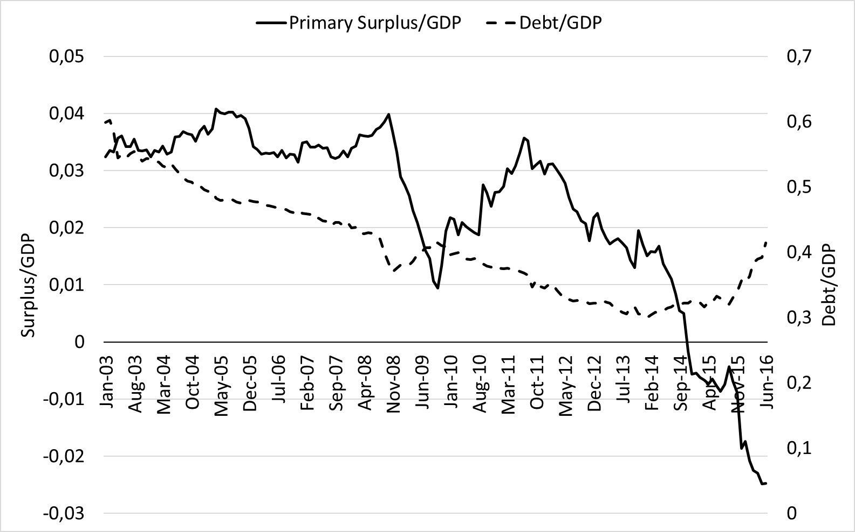

Source: prepared independently, based on Central Bank website data.

The Debt-to-GDP ratio shows a downward trend until the beginning of 2014, when its trajectory reverses. The primary surplus-to-GDP ratio, on the other hand, is generally decreasing over the whole period, a trend accentuated through the end of the sample, corresponding to the period of greatest fiscal deterioration of the Brazilian economy. Another important point to highlight is that the series appear to have some correlation and evolve together most of the period.

Bohn (1998) suggests, as control variables, the output gap - to capture the effect of oscillations in economic activity - and a variable indicative of sudden rises in spending. Both effects were considered here. In order to calculate the output gap ht, we used the monthly estimated GDPprovided by the IBRE/FGV GDP monitor[9]. The potential product  was obtained via Hodrick-Prescott filter, applying the formula: . In turn, to represent the cycles of sudden rise in expenditures, binary variables indicating the election years were used.

One of Bohn's criticisms of sustainability analysis based on unit root tests is that these tests usually do not incorporate other variables affecting the debt trajectory, making it difficult to detect the reversion to the mean. In addition, the fiscal reaction function easily allows for the incorporation of control variables. We list below some controls important for the Brazilian case:[10]

it: basic interest rate (Selic);

it*: implicit interest rate[11];

rt: debt Risk - measure of risk perception associated with debt insolvency, calculated as a ratio between EMBI+ (monthly average) and the rating risk assigned by Standard & Poors’[12];

πt: inflation - monthly series obtained as IPCA relative variation for the previous 12 months;

set: deficit in the current account of the balance of payments or foreign savings;

ttt: terms of trade = ratio between export and import prices.

1. **Methodology**

To estimate the reaction function proposed by Bohn (1998), specified by equation (2.6), it is considered that the coefficients of the function may vary over time, thus allowing for structural changes and discretionary policy, in addition to checking sustainability for subperiods of interest.

Three modeling strategies and estimation methods are used, as presented below.

**4.1 State Space Modeling and Kalman Filter**

The state space representation (Harvey, 1989) is a way of expressing a linear statistical model allowing for the estimation of the parameters at each instant of time.

This representation consists of two equations. The first one is the observation equation, which represents the evolution of the series st over time:

|  |  |
| --- | --- |
|  | (4.1) |

wherein zt is a vector (mx1), αt is a vector (mx1), called the state vector, and εt is a white noise term with zero mean and variance , for t = 1,2,...,T, wherein T is the total number of observations[13]. The second equation is the state transition:

|  |  |
| --- | --- |
|  | (4.2) |

wherein Λt is a matrix (mxm), called state transition matrix and ηt is a vector (mx1) of uncorrelated white noise terms, with zero mean and covariance matrix Qt. The error terms εt and ηt satisfy E(εtηs) = 0mx1, ∀ t,s = 1,2,...,T. The state vector at t = 0, α0, has mean a0 and covariance matrix P0, such that E(εtα0) = 0mx1 and E(ηt) = 0mxm, ∀ t = 1,2,...,T.

In this paper, the equation (4.1) represents the fiscal reaction function, st is the surplus-to-GDP ratio, $z_{t}^{'}$ = (1 bt-1 Xt-1) and αt = (μt ρt )´, wherein μt is the intercept, ρt is the fiscal reaction coefficient and γt is a vector of coefficients of the control variables in Xt-1. We also incorporated, as element of Xt-1, a lagged term of st, to represent a inertial component of surplus-to-GDP ratio.

The equation (4.2) represents the evolution of μt, ρt and γt, where Λt and Qt are diagonal matrices, so that all elements of αt follow - by hypothesis - autoregressive processes of first order and mutually independent. Therefore, (4.1) and (4.2) become:

|  |  |
| --- | --- |
|  | (4.3) |
|  | (4.4) |

wherein φ1 and φ2 are scalars and Φ3 is a diagonal submatrix, whose elements are the coefficients of Xt-1 components, and η1t, η2t and η3t are the elements of the vector ηt in equation (4.2).

These equations are estimated using a method called Kalman filter (Kalman (1960), Kalman and Bucy (1961)). This method consists of predictive and updating - or filtering - equations.

The predictive equations represent the expected value and the variance of the state vector at time t, subject to the available observations up to t-1, denoted by St-1 = {s1, s2, ..., st-1}. Thus:

|  |  |
| --- | --- |
|  | (4.5) |
|  | (4.6) |

The update - or filtering - equations represent the expected value and the variance of the state vector at t, subject to the available observations up to instant t, St = {s1, s2, ..., st}:

|  |  |
| --- | --- |
|  | (4.7) |
|  | (4.8) |

wherein the expression  is called Kalman gain.

For the estimation of the coefficients of the fiscal reaction function, we used the following smoothing equations, which consider the whole sample information ST = {s1, s2, …, sT}:

|  |  |
| --- | --- |
|  | (4.9) |
|  | (4.10) |

The equations (4.9) and (4.10) allows a more efficient estimation than equations (4.7) and (4.8).

The coefficients of Λt shown in equation (4.4), which govern the evolution of each coefficient, are considered constant over time, as well as the variances of error terms. These fixed parameters (hyperparameters) are estimated by the maximum likelihood method (Harvey, 1989).

# 4.2 - Penalized Spline Smoothing

The term "spline" refers to a class of functions used for data interpolation and/or smoothing. An n-degree spline is a piecewise continuous function that joins multiple n-degree polynomials to generate a smooth curve using a finite set of points. In this paper, the coefficient ρ(.) of fiscal reaction is represented by a spline whose components are weighted in such a way to maximize the fit to the surplus observed. Thence:

|  |  |  |
| --- | --- | --- |
|  |  | (4.11) |

wherein ρ(.) is estimated based on the following criterion:

|  |  |  |
| --- | --- | --- |
|  |  | (4.12) |

That is, the quadratic error of the regression is minimized - first term of (4.12) - and the curve is penalized - second term of (4.12). The function ρ(t) is defined in terms of splines basis functions Ψ(t), that are combinations of flexible bands that passes through some control points, creating smooth curves[14]. Then, , where {δj}, j = 1, 2, …, d, are real numbers. Now let:

|  |  |  |
| --- | --- | --- |
|  |  | (4.13) |

and define the matrix Ω, with elements given by (4.13). Thus, the problem in (4.12) becomes:

|  |  |  |
| --- | --- | --- |
|  |  | (4.14) |

whose solution is given by the following system of equations:

|  |  |  |  |  |
| --- | --- | --- | --- | --- |
|  | | | (4.15) | |
|  | | | (4.16) |
|  | |  |

wherein Ωjdenotes thejth line of Ω. The above expressions represent a system of linear equations of p+d order. The parameter λ, in particular, governs the data penalization, in such a way to avoid overstepping– and is estimated by a cross validation procedure. (Hastie and Tibshirani (1990) and Craven and Wahba (1979)). For a survey of model selection criteria, see Hastie et al. (2008).

**4.3 - Time-Varying Cointegration**

Johansen (1988) suggests a method based on the following autoregressive vector model:

|  |  |
| --- | --- |
|  | (4.17) |

where Zt = (Z1t, Z2t, ... ,Zkt) is a vector (kx1) of observations for each series at the instant t, µ is a vector (kx1) of intercepts, Гj , j = 1, ..., p-1, are matrices (kxk) of coefficients of ΔZt-j, and εt is a vector (kx1) of errors, so that εt ~ N(0,Ω). The Johansen test is based on the rank of ∏. If the hypothesis that the matrix has rank r<k is not rejected, we conclude that there are r cointegration vectors. In this case, we can write ∏´ = αβ´, where β is a matrix (kxr), the columns of which are the cointegration vectors and α is a matrix (kxr), the rows of which are vectors measuring the long-term equilibrium adjustment speed.

|  |  |
| --- | --- |
|  | (4.18) |
|  |  |

We consider here a cointegration ratio that may vary over time. Park and Hahn (1999) present a method where the evolution of cointegration vector components are defined by a Fourier series. Such procedure applies only if a single cointegration ration exists between the variables. Bierens and Martins (2010) suggest a more general procedure extending the Johansen method, allowing the incorporation of multiple cointegration relationships considering the model:

the only difference between (4.18) and (4.17) being the fact that matrix Π varies over time. Two aspects should be highlighted in (4.18): the vector of intercepts μ does not varies over time and  = α, so that only β varies over time, with matrix α kept constant. The evolution of β over time is represented by Chebyshev polynomials, defined as: P0,T(t) = 1, Pi,T(t) = 21/2cos(iπ(t-0.5)/T), t = 1,2, ..., T-1. It is proved that any time function can be represented as a linear combination of T-1 Chebyshev polynomials (Hamming, 1973).

|  |  |
| --- | --- |
|  | (4.19) |

In this paper, statistical criteria (Bierens and Martins, 2010) are used to define the number m of polynomials that satisfactorily approximates the trajectory of the coefficient β. Therefore, the evolution of β over time can be represented as:

The higher the value of m, the more precise - however, the less smooth - the approximation. A small value of m imposes a smooth behavior for βt, approaching the invariant case. Therefore, the methodology allows to contemplate different patterns of behavior in the cointegration vector over time, capturing possible long term nonlinear relationships (see Granger(1988)). Substituting (4.19) into (4.18), we have:

|  |  |
| --- | --- |
|  | (4.20) |

where ξ’ = [ξ0’, ξ1’, ..., ξm’] is a matrix [r x (m+1)k], of rank r, = (Z’t-1,P1,T(t)Z’t-1, P2,T(t)Z’t-1, ... ,Pm,T(t)Z’t-1)and Yt = (ΔZ’t-1, ..., ΔZ’t-p+1)’.

1. **Results**

In this paper, we use three estimation strategies for the fiscal reaction function, all considering linear specifications whose coefficients can vary in time, with the variables described in section 3. In all the proposed approaches, the coefficients of all the variables involved are considered to vary over time. This allows not only for the response of the primary-result-to-GDP ratio to the debt-to-GDP ratio, but also for the partial effects of the remaining variables, to vary over time[15].

* 1. **Constant-Coefficient Model**

Firstly, unit root tests were implemented to investigate the non-stationarity hypothesis of the concerned series. The results are shown in Appendix I. We conclude that, except for the output gap series, all other series show non-stationary behavior. Thus, a natural approach is to investigate the existence of a possible long-term relationship between st, bt and, possibly, other variable(s) and, thence, establish an error correction model to estimate together the short and long-term relationships between the variables involved.

The results obtained through the estimation of the model in (4.17) are presented below:

**5.1 - Conventional Error Correction Model**

|  |  |  |  |
| --- | --- | --- | --- |
|  |  |  |  |
|  |  |  |  |
| **Cointegrating Eq:** | **CointEq1** |  |  |
|  |  |  |  |
|  |  |  |  |
| s(-1) | 1.000000 |  |  |
|  |  |  |  |
| b(-1) | -0.054835 |  |  |
|  | (0.00702) |  |  |
|  | [-7.81054] |  |  |
|  |  |  |  |
| se(-1) | 2.11E-05 |  |  |
|  | (7,2E-06) |  |  |
| C | [2.93056]  -0,023867 |  |  |
|  | (0,00935)  [-2.55262] |  |  |
|  |  |  |  |
|  |  |  |  |
| **Error Correction:** | **D(s)** | **D(b)** | **D(se)** |
|  |  |  |  |
|  |  |  |  |
| CointEq1 | -0.024363 | -0.127823 | -0.005615 |
|  | (0.01179) | (0.03499) | (0.00587) |
|  | [-2.06715] | [-3.65341] | [-0.95744] |
|  |  |  |  |
| D(s(-1)) | 0.066173 | -0.382277 | -0.035221 |
|  | (0.08126) | (0.24124) | (0.04044) |
|  | [ 0.81431] | [-1.58464] | [-0.87096] |
|  |  |  |  |
| D(b(-1)) | -0.036445 | 0.036465 | 0.012412 |
|  | (0.02831) | (0.08404) | (0.01409) |
|  | [-1.28738] | [ 0.43390] | [ 0.88100] |
|  |  |  |  |
| D(se(-1)) | 2.60E-09 | 8.99E-09 | 0.409966 |
|  | (7.8E-08) | (2.3E-07) | (0.07435) |
|  | [0.03353] | [ 0.03958] | [-5.51383] |
|  |  |  |  |
| h(-1) | 0.046021 | -0.115643 | 0.008571 |
|  | (0.01201) | (0.03567) | (0.00598) |
|  | [ 3.83039] | [-3.24227] | [ 1.43347] |
|  |  |  |  |
| D(r(-1)) | 0.009336 | -0.122574 | 0.002388 |
|  | (0.02008) | (0.05962) | (0.00999) |
|  | [0.46482] | [-2.05581] | [ 0.23889] |
|  |  |  |  |
|  |  |  |  |

The selected specification indicates the existence of a single cointegration vector between primary surplus/GDP, debt-to-GDP (b) and foreign savings (se), which corresponds to the following long-term relationship: st = 0.023867 + (0.054835)bt - (2.11x10-5)set. The positive sign of the coefficient bt is consistent with a fiscal deficit reducing as the net-debt-to-GDP ratio rises. The negative sign of the current account deficit ratio is justified by its use to finance the deficit.

As for the short-term model, the significant exogenous variables were output gap (h), which is stationary, and debt risk (r), in difference, both lagged in one unit of time. It should be noted that, in addition to the output gap and the correction term of errors, no other coefficients are significant in the D(s) equation. This reflects the fact that the primary result, being the main fiscal policy instrument, played an endogenous role in successive corrections of the fiscal system towards long-term equilibrium.

* 1. **Constant Coefficient Hypothesis Tests**

Before applying the time-varying methods, it is important to test the hypothesis that the reaction function coefficients are constant over time.

For penalized spline smoothing method, the test that compares the estimated model with the linear (constan-coefficient) model uses a statistics that is based on the deviations of the estimates at each moment in relation to the average value in the period. This statistic has asymptotic distribution F with df degrees of freedom (df depends on the data)[16]. For the reference model, this distribution has 2 degrees of freedom. Thus, H0: df = 2 is tested against H1: df > 2, where df stands for degrees of freedom. In this work, H0 was rejected at a significance level of 0.05.

In addition, the estimate of the parameter λ in equation 4.12, by the cross validation procedure mentioned in section 4.2, was 0,253. This value is lower than usual values in empirical papers for other countries. The lower λ, the more distant are the data from the constant-coefficent model, thus this low value evidences a strong sinuousness of fiscal reaction in relation to its mean value.

It is concluded that, at least by the penalized spline smoothing method, the time-varying coefficients approach presents prominent gain, in relation to the constant-coefficients approach.

In the case of the time-varying cointegration method, the appropriate test is: H0: ∏t´ = αβ´ x H1: ∏t´ = αβt´. Under H0 (restrict model), ξ’ = (β’,), where β is a matrix (kxr) whose columns are invariant cointegration vectors, so that, in (4.18), ξ’ = β´, com = Z’t-1. Thus, at H0, all the coefficients of the Chebyshev polynomial are null, except the first, which corresponds to m = 0, or time-invariant cointegration. On the other hand, H1 postulates that at least some of the coefficients {ξiT} in (4.19) are nonzero, thus the cointegration relationship varies over time. To investigate such hypotheses, the wild and sieve bootstrap methods were used (Martins, 2013). The results led to the rejection of H0, indicating a time-varying cointegration vector, at 0.05 level.

* 1. **Time-Varying Methods[17]**

Table 5.2 below presents the averages of the fiscal reaction function coefficient estimates over time, obtained through the methods described in sections 4.1-4.3[18]:

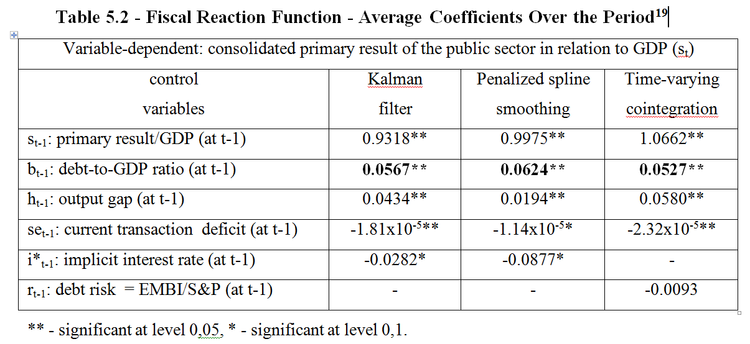

The Debt-to-GDP Ratio coefficient is positive and significant at 0.05 for all methods adopted. This indicates that, given the value of GDP, a debt increase of 1% of GDP corresponds to an increase in the primary surplus between 0.0527% and 0.0624% of GDP. If, however, this fiscal reaction leads to a sustainable trajectory for public debt, is an additional question, which involves the condition set out in section 2.2, equation (2.10), and will be investigated in section 6.

The lagged surplus coefficient (st-1) is significant, indicating a strong inertial component of the primary outcome series, as expected. The output gap coefficient ht is positive and significant, indicating that, in periods of expansion a larger primary surplus is generated, either by increasing revenues or reducing public spending (for example, unemployment insurance). Obviously, the opposite occurs in the case of recession (negative output gap).

The coefficient of the deficit variable in current transactions is negative and significant in all methods, albeit at different levels. A possible explanation is that, when there is a greater acquisition of foreign savings by the economy, it becomes easier to finance government’s deficit.

The simultaneous use of the implicit interest rate and the debt risk was avoided, since this leads to a pronounced inaccuracy of the estimates (high standard errors), due to the strong correlation between them. Accordingly, isolated specifications were estimated for each of them, each method leading to the selection of a different variable for the final model[19].

The coefficient for the inflation variable is not significant for any of the methods, which is in line with the fiscal reaction literature for the case of Brazil in the post-stabilization period (1994). One might expect an inflation effect on tax collection (Tanzi effect) or seigniorage. In the first case, there would be a negative impact on the fiscal reaction. In the second case, a higher inflation could affect the real value of the debt. In this case, the impact would be of a greater fiscal reaction. Apparently, the two effects were insignificant for the levels of inflation observed throughout the study period. Moreover, the effect of electoral years was not significant.

**5.4 Comparison Between Methods**[20]

Figure 5.1 below shows the evolution of the fiscal reaction coefficient over time, according to the three methods adopted in this paper for its estimation (PSS = penalized spline smoothing, KF = Kalman filter and TVC = time-varying cointegration).

**Figure 5.1 - Estimated Fiscal Reaction Coefficient by the Three Methods**

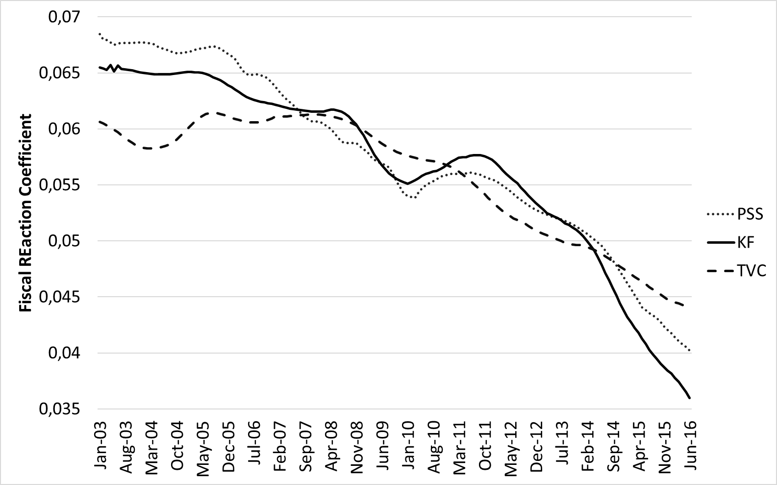

All methods point to a fiscal reaction with a declining trend that has become more pronounced in recent years, especially since 2014, with the Kalman filter indicating a steeper slope.

This section presents a comparison between the three methods used to generate the estimates reported in section 5.3. The objective is to choose the most appropriate method, so that the corresponding results are used to evaluate the sustainability of the debt in the period of study.

The reaction function adjusted by each method was used in this comparison, considering its estimated coefficients at each point in time, and its comparison with the effective primary surplus observed at each instant, using the mean square error and the mean absolute error.

Table 5.3, below, presents the results obtained, showing, notwithstanding the good results from the three methods, the slightly superiority of the Kalman filter in relation to the other.

**Table 5.3 - Adjustment of Each Model to the Fiscal Reaction Observed**

|  |  |  |
| --- | --- | --- |
|  | Mean square error | Mean absolute error |
| Kalman filter | 1.1388 x 10-5 | 0.0029 |
| Penalized spline smoothing | 9.7451 x 10-5 | 0.0046 |
| Time-varying cointegration | 1.8219 x 10-4 | 0.0068 |

Another method used for comparison was the comparison of the pre-specified probabilities of nominal coverage with the effective coverage, also adopting as reference the primary surplus values effectively observed throughout the period. The table 5.4 below illustrates the results:

**Table 5.4 – 95% CI Effective Coverage Probabilities for Each Method**

|  |  |  |
| --- | --- | --- |
|  | Observations outside | Actual/real coverage |
| Kalman filter | 11 | 93.21% |
| Penalized spline smoothing | 13 | 91.98% |
| Time-varying cointegration | 16 | 90.12% |

This criterion also leads to choosing the Kalman filter as the best method, with 11 out of the 162 real values being excluded from the estimated confidence interval, resulting in an effective coverage probability of 93.21%, while the two other methods are farther from the 95% pre-specified nominal coverage probability. The graph below illustrates the result for the best method**.**

**Figure 5.2 - Observed Surplus vs. 95% Confidence Interval via Kalman filter**

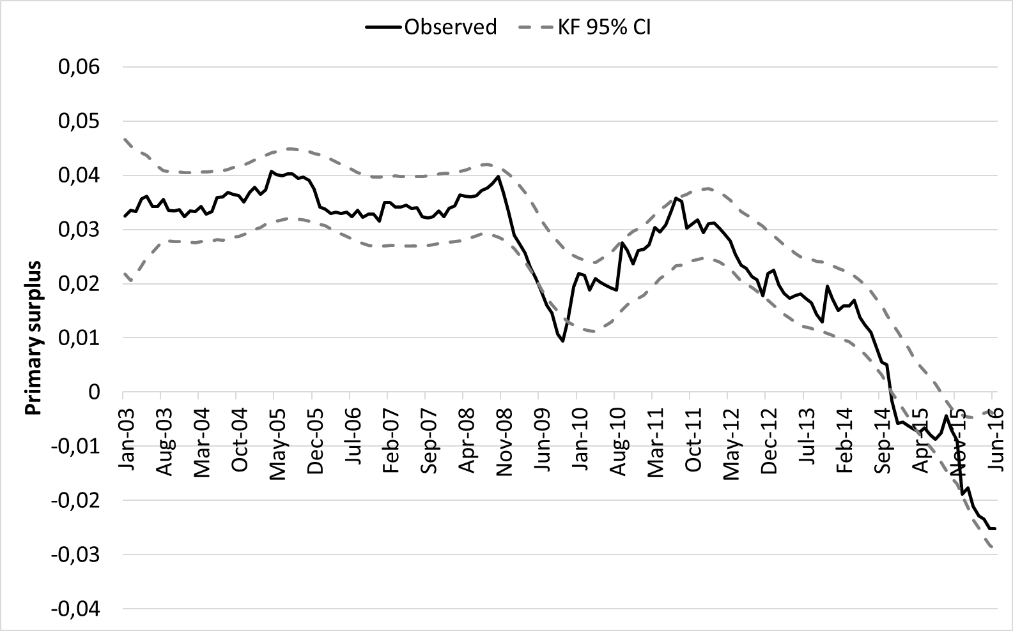

Points falling outside the range correspond to critical periods from November 2014 to March 2015 and June to October 2009, plus a single point in November 2012.

* 1. **Model Adjustment and Implications in Monetary Terms**

The Figure below illustrates a comparison between the fiscal reaction estimated by the smoothing algorithm of Kalman filter and the primary surplus observed.

**Figure 5.3 - Observed vs. Kalman Filter Estimated Primary Surplus**

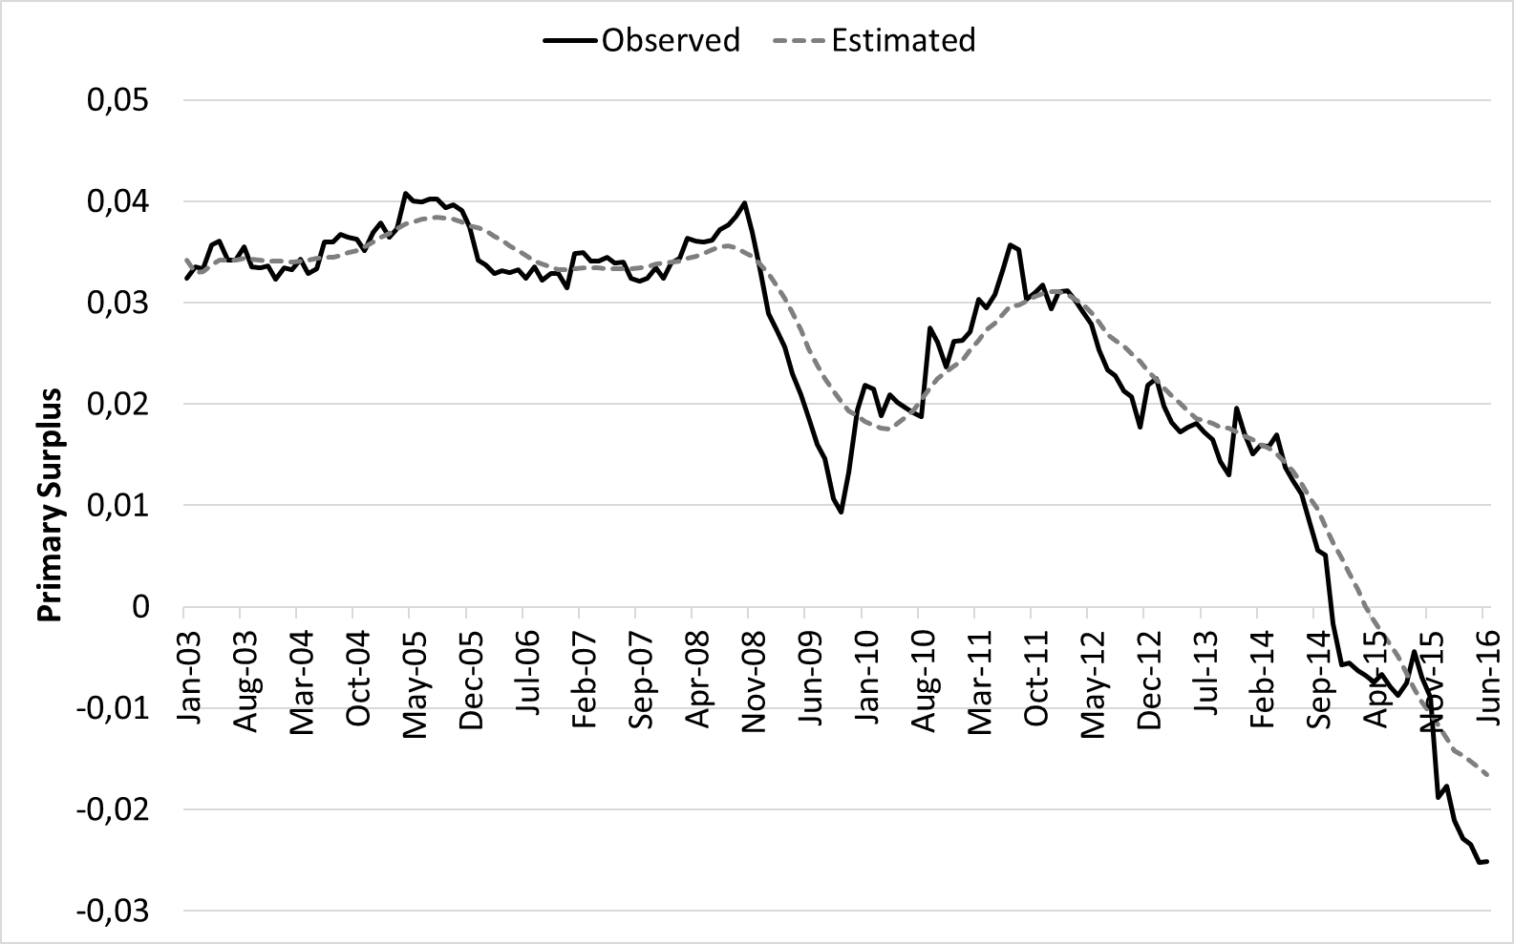

For practical illustration, we present in the remaining part of this section and in the following section (Section 6) some data based on the estimation by Kalman filter.

In the period reviewed, the consolidated net debt of public sector increased approximately 5% of GDP (around 316 billion of reais, for a GDP of around 6.32 trillion of reais). Following our calculations, this leads to a marginal increase in the consolidated primary surplus of the public sector around 0.28% (17.92 billion of reais) of the GDP. A direct conclusion deriving from this result is that it is well below what the country needed to stabilize the net-debt-to-GDP ratio at the end of 2016.

In fact, as the equation (2.5) shows, and considering that the real interest rate at the end of 2016 far exceeded the growth rate of the product, the stabilization of the net debt-to-GDP ratio would require a primary surplus sufficient to pay at least part of the actual interest on the debt (i.e., ).

However, in 2016 there was no primary surplus, but rather a deficit of approximately 157 billion of reais. Accordingly, the average reaction of 17.92 reais of primary surplus to a rise in net debt of 5% of GDP is hardly a relieving data.

Let us now move from the average value of the fiscal reaction to the value estimated by the model, which may vary from period to period. Figure 5.4 shows the estimated changes in the primary surplus due only to the reaction function, period-to-period, in Reais of average purchasing power of 2016, given an increase of net debt around 5% of GDP:

**Figure 5.4 - Fiscal Reaction to an Increase of Debt of 5% of GDP**

**(Values in Reais of 2016)**

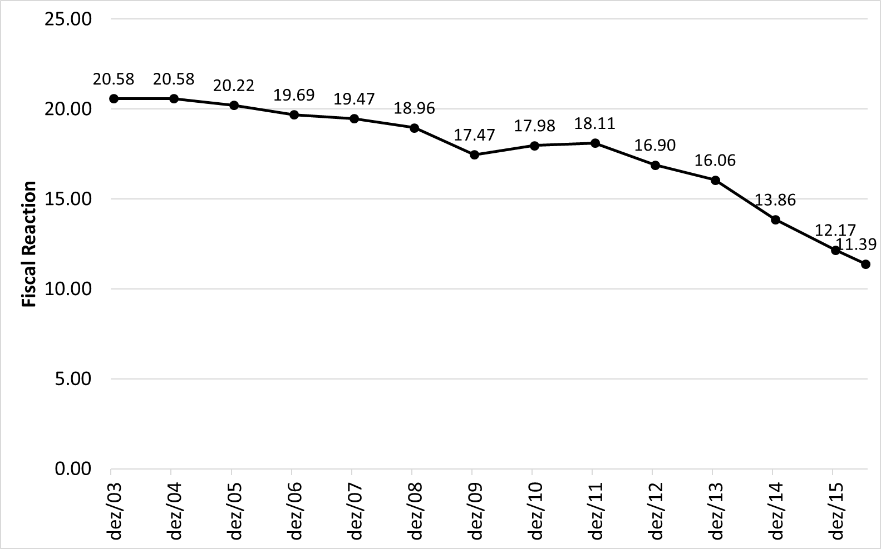

As one might predict, based on the previous theoretical results, the fiscal reaction has declined over time, which is not something positive in the context of an attempt to stabilize the net-debt-to-GDP ratio.

1. **Sustainability Analysis**

Although, as mentioned earlier, the results presented at the end of the previous section and in this one are based only on the Kalman filter method (which provided the best results) the conclusions of the other methods adopted were basically the same. This applies with respect to the sustainability of debt in each period of interest.

The analyses made in this section are based on the strong assumptions that the variables considered based on the observations of a given period, are supposed to remain constant in the long run. We use two different concepts of interest rates, the Selic rate and the implicit interest rate on the net debt. It is important to note that the previous calculations of the fiscal reaction did not depend on this choice, since the interest rate variable was not statistically relevant for the estimation. Such a choice, however, will be important for the conclusion about debt sustainability, as we will see below.

An important advantage of estimation with variable coefficients is that it allows for the sustainability conditions to be checked for different subperiods. This is important because the conclusions may differ depending upon the period. Indeed, we can get different mean values of the fiscal reaction ρ for different points in time, the same applying to interest rates and GDP growth. Sustainability analysis does not need to be restricted to the entire period averages.

We use, as a criterion of sustainability, the approximation given by (2.10), and consider the average value of the fiscal reaction coefficient estimated over the period considered, comparing it with the difference between the average values of the nominal (logarithmic) interest rate (i) and the (logarithmic) growth rate of nominal GDP (θ).

Let us take, to start with, the entire period of estimation. Accordingly, consider the estimated average fiscal reaction between January 2003 and June 2016, which was 5.67%. Taking the Selic as an interest rate, we have a mean (i-θ), for the same period, of 12.31 – 10.80 = 1.51%, which indicates (considering a fiscal reaction value of 5.67) a sustainable trajectory throughout the study period.

If, on the other hand, the analysis is restricted to a more recent period of the Brazilian economy (say, as of January 2012), the average of the estimated fiscal reaction coefficients is recalculated considering only the values in this sub-sample, and the result is now 4.75%, from a mean (i-θ), for the same period, of 10.11 – 8.16 = 1.95%. Again, we have a sustainable behavior, despite the strong reduction in the mean fiscal reaction.

However, analyzing Figure 5.1, the three estimation methods provide indications of a more pronounced decline in the fiscal reaction coefficient as of 2014. In fact, if sustainability analysis is redone for the period between January 2014 and June 2016, the conclusion is reversed.

Although a substantial drop in the average of the coefficient of fiscal reaction estimates (from 4.75 to 4.27%) is not observed, the combination of the increase of the interest rate in the period with the fall in GDP results in a mean difference of 6.10% (= 12.79% - 6.69%) in the period, well above the estimated fiscal reaction coefficient. In this case, the indication is of an unsustainable trajectory.

It is worth mentioning that, although the Selic rate is generally higher than the effective rate on consolidated government gross debt, the same is not true when we consider the net debt. The Central Bank calculates an implicit interest rate on this type of debt. As the quality of liabilities tends to be higher than the quality of public assets (hence many publications are based on gross debt, rather than net debt), the implicit interest rate on net debt tends to be higher than the Selic.

Neverthless, if we use the implicit rate, instead of the Selic, the conclusions about sustainability are similar, except for the period between January 2012 and June 2016. Tables 6.1 and 6.2 summarize the results considering both interest rates and different periods of analysis.

**Table 6.1 - Public Debt Sustainability per Sub-Period (interest rate = Selic)**

|  |  |  |  |
| --- | --- | --- | --- |
|  | SINCE JAN 2003 | SINCE JAN 2012 | SINCE JAN 2014 |
| SELIC (ln) | 12,31 | 10,11 | 12,79 | |
| % (Nominal) GDP (ln) | 10,80 | 8,16 | 6,69 | |
| FISCAL REACTION | 5,67 | 4,75 | 4,27 | |
| SELIC– PIB | 1,51 | 1,95 | 6,10 | |
| SUSTAINABILITY (SELIC- GDP < FISCAL REACTION) | SUSTAINABLE | SUSTAINABLE | UNSUSTAINABLE | |

**Table 6.2 - Public Debt Sustainability per Sub-Period (implicit interest rate)**

|  |  |  |  |
| --- | --- | --- | --- |
|  | SINCE JAN 2003 | SINCE JAN 2012 | SINCE JAN 2014 |
| IMPLICIT (ln) | 15.68 | 17.86 | 20.39 |
| % (Nominal) GDP (ln) | 10.80 | 8.16 | 6.69 |
| FISCAL REACTION | 5.67 | 4.75 | 4.27 |
| IMPLICIT– GDP | 4.88 | 9.70 | 13.70 |
| SUSTAINABILITY (SELIC- GDB < FISCAL REACTION) | SUSTAINABLE | UNSUSTAINABLE | UNSUSTAINABLE |

We conclude that, regardless of the interest rate or the estimation method adopted, the public debt reaches an unsustainable trajectory at the end of the sample. However, it should be noted that, despite the notable decline in the fiscal reaction observed in Figure 5.1, cyclical factors such as the fall in GDP growth and the increase in the interest rate contributed strongly to this result.

Particularly in the case of the Selic-based analysis, the transition to unsustainability as of January 2014 (in relation to the period beginning in January 2012) is due to changes in GDP and interest rates (with i-θ rising from 1.95% to 6.10%), rather than to fiscal reaction coefficient variation. Actually, the latter changes very little between these two periods, from 4.75 to 4.27.

**7. Conclusions**

This paper contributes to the literature regarding fiscal policy in Brazil in three different dimensions.

First, it provides estimates of time-varying fiscal reaction functions for the Brazilian economy. The use of time-varying coefficients has the advantage of allowing for statistical analyses of debt sustainability for different subsets of the data. For instance, restricting the sample to 2014-2016 indicates a nonsustainable debt trajectory. This conclusion, though, does not follow from an analysis considering the whole sample.

A second contribution is exemplifying how three different estimation methods (all of which allowing for coefficients to vary over time) may be used to calculated the fiscal reaction function. The fact that they lead practically to the same results confers robustness to the results here presented.

Third, the analysis also reveals how important interest rates and GDP growth may be for the sustainability of the debt to GPD ratio.

A fourth contribution is of a normative nature. The study suggests the necessity of a strong reversal of the fiscal reaction process in Brazil. Of course, this implies dealing with political, as well as institutional challenges.

It would be interesting, in future work, to use different public sector and debt definitions, as well as a greater temporal amplitude.

# 8.Bibliographic References

Adedeji, Olumuyiwa S., and Oral Williams. "Fiscal Reaction Functions in the CFA Zone: An Analytical Perspective." *IMF Working Papers*, October 2007: 21.

Afonso, António, and Sebastian Hauptmeier. "Fiscal behaviour in the European Union: rules, fiscal decentralization and government indebtedness." *ECB Working Paper*, May 7, 2009: 47.

Akaike, Hirotugu. "Fitting autoregressive models for prediction." *Annals of the institute of Statistical Mathematics*, June 17, 1969: 5.

Banco Central do Brasil. *Dívida líquida e bruta do governo geral.* 2016. https://www3.bcb.gov.br/sgspub.

Banco Central do Brasil. "Relatório de Indicadores Fiscais de junho/2016." 2016.

—. *Sistema Gerenciador de Séries Temporais (código 4189).* 2016. https://www3.bcb.gov.br/sgspub.

Bierens, Herman J., and Luis Filipe Martins. "Time-Varying Cointegration." *Econometric Theory*, 2010: 1453-1490.

Blanchard, Olivier, Jean-Claude Chouraqui, Robert Hagemann, and Nicola Sartor. "The sustainability of fiscal policy: New answers to an old question." *OECD Economic Studies*, 1990.

Bohn, Henning. "Are stationarity and cointegration restrictions necessary for the intertemporal budget constraint?" *Journal of Monetary Economics*, 2007: 1837-1847.

Bohn, Henning. "The Behavior of U.S. Public Debt and Deficits." *The Quarterly Journal of Economics* (Oxford University Press) 113, no. 3 (1998): 949-963.

Boor, Carl de. *A practical guide to splines.* Revised. Springer, 2001.

Budina, Nina, and Sweder van Wijnbergen. "Quantitative approaches to fiscal sustainability analysis: a case study of Turkey since the crisis of 2001." *World Bank Economic Review*, 2008: 119-140.

Burger, Philippe, and Marina Marinkov. "Fiscal rules and regime-dependent fiscal reaction functions: The South African case." *OECD Journal on Budgeting*, 2012: 31.

Cantoni, Eva, and Trevor Hastie. "Degrees-of-freedom tests for smoothing splines." *Biometrika*, June 1, 2002: 251-263.

Cavalcanti, Marco A. F. H., and Napoleão L. C. Silva. "Dívida pública, política fiscal e nível de atividade: uma abordagem VAR para o Brasil no período 1995-2008." *Economia Aplicada*, Outubro/Dezembro 2010: 391-418.

Craven, Peter, and Grace Wahba. "Smoothing noisy data with spline functions: Estimating the correct degree of smoothing by the method of generalized cross-validation." *Numerische Mathematik*, December 1978: 377–403.

Davig, Troy, and Eric M. Leeper. "Endogeneous monetary policy regime change." Chap. 6 in *NBER International Seminar on Macroeconomics 2006*, edited by Lucrezia Reichlin and Kenneth West, 345 - 391. University of Chicago Press, 2008.

Dill, Helena Cristina. "Política fiscal, dívida pública e a atividade econômica." *Master's Essay.* Paraná: Universidade Federal do Paraná, August 11, 2012.

Égert, Balász. "Fiscal Policy Reaction to the Cycle in the OECD: Pro- or Counter-cyclical?" *OECD Economics Department Working Papers*, May 6, 2010: 47.

Eilers, Paul H. C., and Brian D. Marx. "Flexible smoothing with B-splines and penalties (with comments and rejoinder)." *Statistical Science*, 1996: 89-121.

Elliot, Graham, Thomas J. Rothemberg, and James H. Stock. "Efficient tests for an autoregressive unit root." *Econometrica*, July 1996: 813-836.

Fincke, Bettina, and Alfred Greiner. "How to assess debt sustainability? Some theory and empirical evidence for selected euro area countries." *Applied Economics*, 2012: 3717-3724.

Granger, Clive William John. "Developments in the Study of Cointegrated Economic Variables." *Oxford Bulletin of Economics and Statistics*, August 1986: 213-218.

Greiner, Alfred, and Göran Kauermann. "Sustainability of US public debt: estimating smoothing spline regressions." *Economic Modelling*, March 2007: 350-364.

Hamilton, James D., and Marjorie A. Flavin. "On the limitations of government borrowing: a framework for empirical testing." *American Economic Review*, September 1986: 808-819.

Hamming, Richard Wesley. *Numerical Methods for Scientists and Engineers.* Second. New York: McGraw-Hill, Inc., 1973.

Harvey, Andrew C. *Forecasting, Structural Time Series Models and the Kalman Filter.* Cambridge: Cambridge University Press, 1989.

Hastie, Trevor, and Robert Tibshirani. "Varying-coefficient models." *Journal of the Royal Statistical Society. Series B (Methodological)*, 1993: 757-796.

Hastie, Trevor, Robert Tibshirani, and Jerome Friedman. *The Elements of Statistical Learning. Data mining, inference and prediction.* Second. New York: Springer-Verlag, 2009.

IBGE. 2016. https://seriesestatisticas.ibge.gov.br/.

Instituto Brasileiro de Economia. "Monitor do PIB/FGV." *Portal IBRE.* n.d. http://portalibre.fgv.br/main.jsp?lumChannelId=8A7C82C5593FD36B015D5C57E75715CA.

Issler, João Vitor, and Luiz Renato Lima. "Public debt sustainability and endogenous seigniorage in Brazil: time series evidence from 1947-92." *Journal of Development Economics*, June 2000: 131-147.

Jesus, Cleiton Silva de. "A Macroeconomia da Política Fiscal: Modelo Dinâmico e Evidências para o Brasil." *Concurso de Monografia em Finanças Públicas.* 2013. 78.

Johansen, Soren. "Statistical Analysis of Cointegration Vectors." *Journal of Economic Dynamics and Control*, 1988: 231-254.

Kalman, Rudolf Emil. "A New Approach to Linear Filtering and Prediction Problems." *Journal of Basic Engineering*, 1960: 35-45.

Kalman, Rudolf Emil, and Richard S. Bucy. "New Results in Linear Filtering and Prediction Theory." *Journal of Basic Enginnering*, 1961: 85-108.

Khalid, Mahmood, Wasim Shahid Malik, and Abdul Sattar. "The Fiscal Reaction Function and the Transmission Mechanism for Pakistan." *The Pakistan Development Review*, 2007: 435-447.

Lima, Luiz Renato, and Andrei Simonassi. "Dinâmica não-linear e sustentabilidade da dívida pública brasileira." *Pesquisa e Planejamento Econômico*, August 2005: 227-244.

Lopes, Denilson Torcate. "Função de reação da política fiscal e intolerância da dívida: o caso brasileiro no período pós-real." Ribeirão Preto: Universidade de São Paulo, 2007.

Luporini, Viviane. "A Sustentabilidade da Dívida Mobiliária Federal Brasileira: Uma Investigação Adicional." *Análise Econômica*, 2001: 69-84.

—. "Sustainability of Brazilian Fiscal Policy, Once Again: Corrective Policy Response Over Time." *Estudos Econômicos*, April/June 2015.

Martins, Luis Filipe. "Bootstrap Tests for Time Varying Cointegration." *Econometric Reviews*, 2018: 466-483.

Megale, Caio. "Fatores externos e risco-país." *27th BNDES Economics Award.* Rio de Janeiro: PUC-Rio, 2003. 96.

Mello, Luiz de. "Estimating a fiscal reaction function: the case of debt sustainability in Brazil." *Applied Economics*, 2008: 271-284.

Mendonça, Mário Jorge Cardoso de, Cláudio Hamilton Matos dos Santos, and Adolfo Sachsida. "Revisitando a função de reação fiscal no Brasil pós-Real: uma abordagem de mudanças de regime." *Estudos Econômicos*, October/December 2009: 873-894.

Mutuku, Cyrus. "Assessing fiscal policy cyclicality and sustainability: a fiscal reaction function for Kenya." *Journal of Economics Library*, 2015: 173-191.

Ng, Serena, and Pierre Perron. "LAG Length Selection and the Construction of Unit Root Tests with Good Size and Power." *Econometrica*, December 12, 2003: 1519-1554.

Nguyen, Pascal. "Macroeconomic factors and Japan's industry risk." *Journal of Multinational Financial Management*, April 2007: 173-185.

Ourives, Lígia Helena da Cruz. "A Sustentabilidade da Dívida Pública Brasileira na Presença de Déficit Quase-Fiscal." *Public Finance: VII National Treasury Award.* Vol. 1. Brasília: Universidade de Brasília, 2003. 15-79.

Park, Joon Y., and Sang B. Hanh. "Cointegrating Regressions with Time Varying Coefficients." *Econometric Theory*, 1999: 664-703.

Penalver, Adrian, and Gregory Thwaites. "Fiscal rules for debt sustainability in emerging markets: the impact of volatility and default risk." *Bank of England Working Paper*, September 2006: 26.

Penha Cysne, Rubens, and Carlos Thadeu de F. Gomes. "Brasil: O Custo do Atraso no Equacionamento da Questão Fiscal." *Brazilian Journal of Political Economy*, October/December 2017: 704-718.

Rocha, Fabiana. "Long-run limits on the Brazilian government debt. Revista Brasileira de Economia." *Revista Brasileira de Economia*, October 1997: 447-470.

Simonassi, Andrei Gomes. "Função de resposta fiscal, múltiplas quebras estruturais e a sustentabilidade da dívida pública no Brasil." *XXXV Encontro Nacional de Economia.* Recife, 2007.

—. "Reação fiscal sob mudanças estruturais e a solvência da economia brasileira." *Mimeo.* Ceará: CAEN/UFC, 2013.

Song, Joonhyuk. "An Empirical Evaluation of Fiscal Sustainability Near and Far." *The Korean Economic Review*, 2009: 133-164.

Stoica, Tiberiu, and Alexandru Leonte. "Estimating a fiscal reaction function for Greece." *International Proceedings of Economics Development and Research*, 2011: 391-395.

Tesouro Nacional. "Various works." 2016.

*The Annals of Statistics.* "Linear smoothers and additive models (with discussion)." June 1989: 453-510.

Trehan, Bharat, and Carl E. Walsh. "Testing intertemporal budget constraints: theory and applications to U.S federal budget and current account deficits." *Journal of Money, Credit and Banking*, May 1991: 206-223.

Turrini, Alessandro. "Fiscal policy and the cycle in the Euro Area: the role of government revenue and expenditure." *Economic Papers*, May 2008.

Uctum, Merih, Thom Thurston, and Remzi Uctum. "Public debt, the unit root hypothesis and structural breaks: a multi-country analysis." *Economica*, January 20, 2006: 129-156.

|  |  |  |  |  |  |  |  |  |  |  |  |  |  |
| --- | --- | --- | --- | --- | --- | --- | --- | --- | --- | --- | --- | --- | --- |
| **Appendix I - Unit Root Tests** | | | | | | | | | | | | | |
| **Variables** | **ADF** | | |  | **DF-GLS** | |  | $$MZ_{α}$$ | |  | **KPSS** | |
|  | ***Standard*** | ***C*** | ***LT*** |  | ***C*** | ***LT*** |  | ***C*** | ***LT*** |  | ***C*** | ***LT*** |
| Output Gap (ht) | -3.57*** | -3.24** | -3.8** |  | -1.92* | -3.39** |  | -7.07* | -18.9** |  | 0.17 | 0.08 |
| Inflation (ht) | -1.06 | -2.05 | -2.82 |  | -1.86* | -2.39 |  | -6.13* | -12.14 |  | 0.66** | 0.19** |
| Debt Risk (rt) | -1.19 | -2.08 | -3.21* |  | -1.17 | -2.45 |  | -3.06 | -9.94 |  | 0.75*** | 0.21** |
| Debt/GDP (bt) | -0.91 | -1.93 | -3.27* |  | -0.89 | -1.97 |  | -5.52 | -12.1 |  | 1.45*** | 0.32*** |
| Surplus/GDP (st) | -1.02 | -1.97 | -3.18* |  | -1.01 | -2.22 |  | -4.27 | -10.9 |  | 1.04*** | 0.27*** |
| F. Savings (set) | -1.71* | -2,65* | -3,23* |  | -1.51 | -2.52 |  | -1.27 | -9.9 |  | 0.49** | 0.16** |
| Selic (it) | -1.75* | -2.62* | -3.17* |  | -1.78* | -2.87* |  | -5.59 | -14.54* |  | 0.98*** | 0.29*** |
| Int. Implied (it*) | -1.55 | -2.46 | -2,99 |  | -1.69* | -2.74* |  | -5.36 | -12.53 |  | 1.18*** | 0.31*** |
| **Critical Values** |  |  |  |  |  |  |  |  |  |  |  |  |
| 1% | -2.58 | -3.47 | -4.02 |  | -2.58 | -3.50 |  | -13,8 | -23.8 |  | 0.74 | 0.22 |
| 5% | -1.94 | -2.88 | -3.44 |  | -1.94 | -2.97 |  | -8.1 | -17.3 |  | 0.46 | 0.15 |
| 10% | -1.62 | -2.58 | -3.14 |  | -1.62 | -2.68 |  | -5.7 | -14.2 |  | 0.35 | 0.12 |
| **Notes:** 1) *C* and *LT* indicates that the relevant auxiliary regressions contains a constant and a constant and a linear trend respectively while standard means no constant and no linear trend were included; 2) ADF is the standard Augmented Dick-Fuller test, DF-GLS is the modified ADF test proposed by Elliot, Rothemberg and Stock (1996), $MZ_{α}$ is a modification of the Phillips-Perron test proposed by Ng and Perron (2001) and KPSS is the standard KPSS test; 3) Values presented are the test statistics; 4) The null hypothesis of tests ADF, DF-GLS and $MZ_{α}$ is that the series has a unit root, while the null for the KPSS test is that the series is stationary; 5) Significance levels are 10%(*), 5%(**) and 1%(***). | | | | | | | | | | | | | |
| |  |  | | --- | --- | | **Variable** | **Estimate** | | Intercept (µt) | φ1 = -0.0239 | | Debt/GDP (bt) | φ2 = 0.9537 | | Surplus/GDP at t-1 (st-1) | φ31 = 0.9956 | | Foreign Savings (set) | φ32 = 0.8347 | | Output Gap (ht) | φ33 = -0.9741 | | Debt Risk (rt) | φ34 = 0.7782 |   **Appendix II - Maximum Likelihood Estimates of the coefficients of Tt in equation (4.2)** | | | | | | | | | | | | | |

1. Professor at ENCE/IBGE and FGV/EPGE. E-mail: eduardolimacampos@yahoo.com.br.
2. Professor at FGV/EPGE. E-mail: rubens.cysne@fgv.br.
3. Other criticisms of Bohn (2007) regarding the approach based on unit root tests are their low power and sensitivity to sample size, possible non-stationarity related to factors that are not related to the fiscal policy carried out and the fact that, under the conventional formulations, structural breaks - frequent in emerging economies - are not allowed.
4. For additional references, see, for international cases: Davig and Leeper (2006), Penalver (2006), Thwaites (2006), Uctum, Thurston and Uctum (2006), Adedeji and Williams (2007), Khalid et al. (2007), Greiner and Kauermann (2007), Nguyen (2007), Budina and Wijnbergen (2008), Turrini (2008), Afonso and Hauptmeier (2009), Song (2009), Egert (2010), Stoica and Leonte (2010), Burger et al. (2011), Mutuku (2015); and, for the Brazilian case: Luporini (2001), Aguiar (2007), Lopes (2007), Dill (2012) and Jesus (2013).
5. Consider Bt as the gross debt would imply disregarding the government assets and the remuneration thereof, which would result in the equation (2.1) becoming just an approximation for the debt evolution. Equation (2.1) applies only to net debt, assuming equal interest rates accruing on government’s assets and liabilities.
6. Bohn (1998) specifies the function with bt, and not bt-1, on the right side. However, to circumvent the problem of simultaneous causality, several applied works consider lagged debt-to-GDP ratio, which, in fact, makes more sense.
7. As we use here a partial-equilibrium model of debt evolution, there is a symmetry with respect to the cause of the surplus generated. The reaction function does not establish whether surpluses are generated by an increase in revenue or a containment of expenses. As a possible alternative, for example, Nguyen (2007) and Jesus (2013) (see footnote 4) specify their fiscal reaction functions with revenue and expenditure, respectively, as dependent variable.
8. For simplicity, the term γXt is supposed to be convergent and is omitted in the stability analysis; for the present purpose we are only interested in the characteristic root of the homogenous difference equation in bt .
9. Some studies use the industrial production index or IBC-Br of the Brazilian Central Bank, however these series are only proxies for the Real GDP.
10. Sources - Net consolidated debt of the public sector, nominal gross domestic product, annualized implicit interest rate, export volume and net external liabilities: <http://www.bcb.gov.br>; consolidated primary surplus of the public sector: <http://www.tesouro.fazenda.gov.br>; EMBI: <http://www.ipeadata.gov.br>; S&P ratings: <https://www.standardandpoors.com>; Inflation: <http://www.ibge.gov.br> and exchange terms: [www.funcex.org.br](http://www.funcex.org.br).
11. In Brazil, this implicit rate is quite different from the Selic it, and this difference is accentuated when considering net debt. It is assumed that it is the gross rate on public debt, i.e., without deducing the portion that returns to the government in the form of taxes on interest, such taxes being included in the variable Tt. It should be pointed out that the alternative of considering it as the net rate, not including in Tt the taxes on interest, do not change the results.
12. See Lopes (2007), and Megale (2003). The EMBI+ is an index based on debt securities issued by emerging countries, reflecting the difference between the rate of return on these securities and the US Treasury. The classifications have been converted into a numerical variable as follows: D (defaulter) = 0; SD = 1; CC = 2; CCC- = 2.5; CCC = 3; CCC+ = 3.5; B- = 4; adding 1 point for each promotion. For the positive (negative) concepts attributed by S&P, an increase (decrease) of 0.25 is considered.
13. In order to simplify the exposition, we omit some terms in space state representation.
14. For details, see Eilers, P.H.C. and Marx, B.D. (1996).
15. Greiner and Finckler (2015), for example, implement the penalized spline smoothing method with restrictions, considering that only the fiscal reaction coefficient varies over time, keeping the remaining ones constant.
16. Cantoni and Hastie (2002).
17. To implement the Kalman filter and penalized spline smoothing, the dlm and mgcv functions of R software, respectively, were used. Time-varying cointegration was Implemented in EasyReg software, version 2015 (<http://personal.psu.edu/hxb11/ERIDOWNL.HTM>). The specification used was the same selected in section 5.1.
18. The hyperparameters (coefficients of matrix Tt in equation (4.2)) estimates are reported in Appendix II.
19. Both variables may be reflecting the increased perception of insolvency risk, which, in turn, makes government bonds less attractive, which becomes an obstacle to debt growth. Indeed, it is noted that, in the bivariate model of table 5.1, these variables are not significant in the D(s) equation, but they are in the D(b) equation.
20. According to Bierens and Martins (2010), the time-varying cointegration vector can be interpreted as both a possible approximation for a long-term nonlinear relationship, as well as a linear relation whose coefficients may vary over time. This last interpretation is common to all three approaches, making it possible to compare them.